**NAME:Fathi Abdullahi Mohamuud .**

**ASSIGNMENTONE: DATABASE COURSE**

**ONE TO ONE :**

**STUDENT.**

* **Studentid**
* **Studentname**

**STUDENTUDCARD:**

* **Id**
* **Universityname**
* **Studentid**
* The two table of student and studentidcard have one to one relational data of(studentid).
* **The table that is being linked is “student “ and it is connected by the table of the studentidcard.**

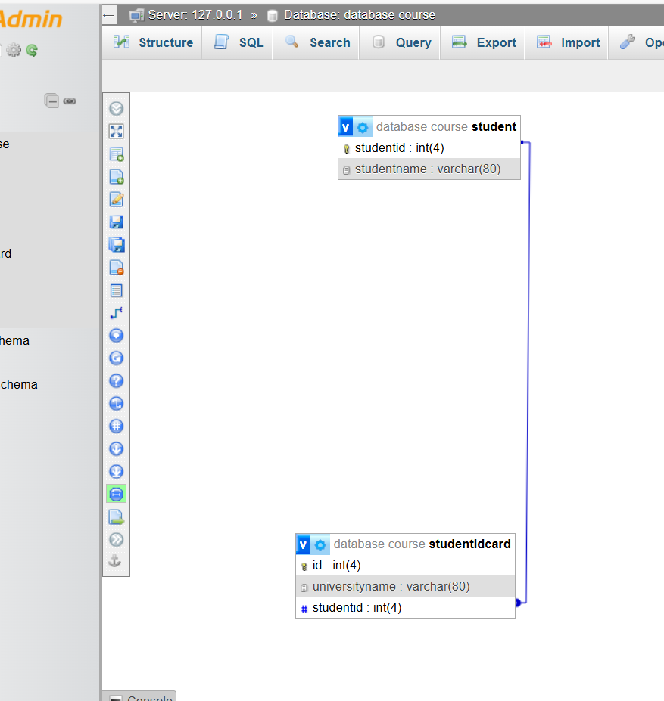

**One to many:**

Parents

* parentid
* name

**children**

* childid
* childname
* parentid
* The two table above of parent and children have one to many relational data of(parentid).
* It is one to many because of one parent can have many children and and many children have one parent.
* **The table that is being linked is “parent “ and it is connected by the table of the children.**

**The picture below shows one to many relationship of(parent and children).**

* 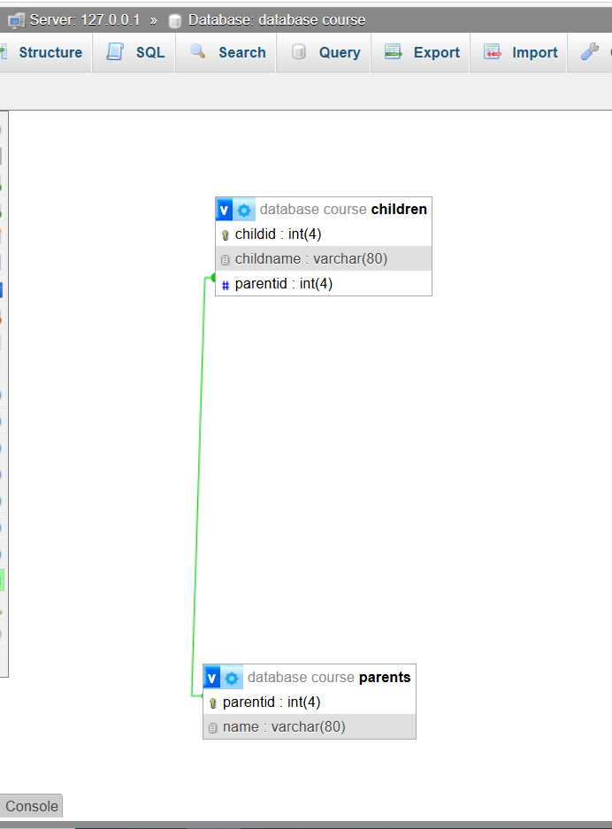

**Many to many:**

**1.Students**

* Studentsid
* Studentsname

**2.teacher**

* Teacherid
* Teachername

**3.subjects**

* Subjected
* Subjectname
* Teacherid
* Studentsid

* The three table above shows many to many relation of (teacherid and studentsid.
* **The table that is being linked is “subjects”, and it is connected to the other two table.**

**The picture below shows many to many relationship of (students,teacher and subjects):**

